FORD MOTOR COMPANY

ROLLER TURN ROLLER KIT

FORD MI SC 613324

ESD 88-5920

**Kit Roller Turn Roller**

2.75” OD x 2.125” LTB x .500 (1/2”) bore

With thin hex head bolt, zerk in bottom, jam nut and star lock washer

**MI SC 613324**

ESD 88-5920



LOADBAR ASSEMBLY

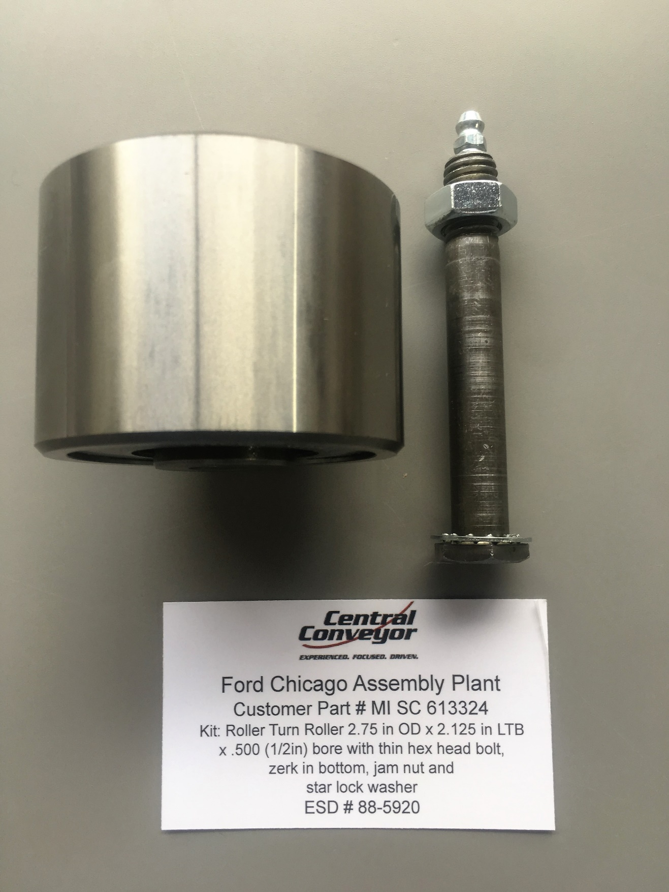



REAR TROLLEY ASSEMBLY

GM LDT BODY SHOP OHPF DELIVERY

15-4361U2BDOO1